*GREEN VALLEY*

*RECYCLING & DISPOSAL SERVICE, INC.*

***www.gvds.biz***

Recycle Hassle

* Need to sort materials
* Small bins
* Material blowing all over the neighborhood
* Heavy and wet to handle
* Hard to carry to the curb

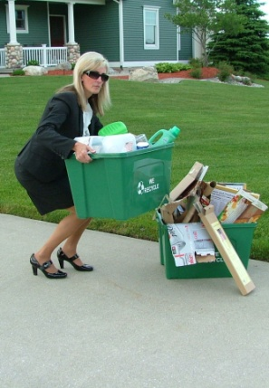

OR…

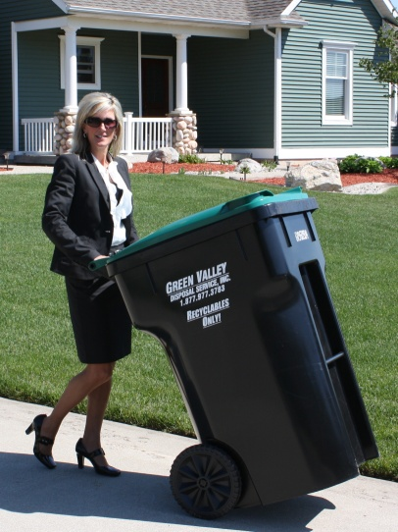

***RECYCLE-EASY***

* **NO SORTING**!! All of your metal, glass, plastic and paper go int one container!
* Large, easy to roll container
* Hinged cover keeps material dry
* RECYCLE-EASY cart can stay outside
* Saves landfill space
* ONLY $4.14 per month, the same price as the small bin!

Introducing the new, easy way to recycle, RECYCLE-EASY, from Green Valley Recycling & Disposal Service!

No more small bins, no more loose recycling material blowing across your lawn. We provide a 96 gallon RECYCLE-EASY container which can easily hold your recycling material from pickup to pickup, and the best part, NO MORE SORTING! Call the village office at 642-6324 TODAY to start RECYCLE-EASY at your home. Do your share to fight pollution, save our natural resources and keep reusable material from being lost forever in the landfill.

*GREEN VALLEY*

*RECYCLING & DISPOSAL SERVICE, INC.*

***PRESENTS:***

*RECYCLE-EASY*

***THE NEW, CLEAN AND CONVENIENT WAY TO RECYCLE!***

***Green Valley Recycling &***

***Disposal Service, Inc***

***PO Box 602***

***Comstock Park, MI 49321-0602***

***www.gvds.biz***

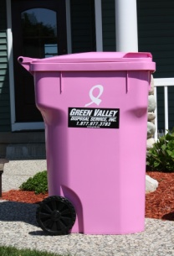

***Show your support for Breast Cancer research,***

***Order your Pink Cart today, and help find a cure!***

